Assignment 5
1) Write a query that will give you all orders for more than Rs. 1,000.
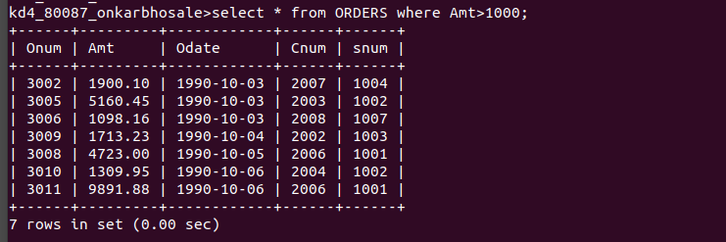

2) Write a query that will give you the names and cities of all salespeople in London with a commission above .10.
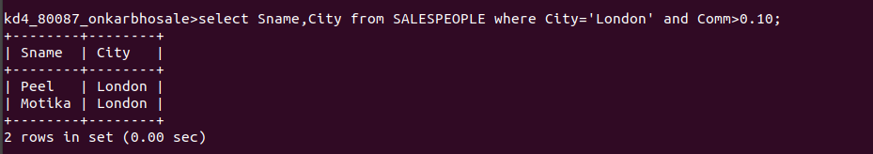

3) Write a query on the Customers table whose output will exclude all customers with a rating <= 100, unles they are located in Rome.
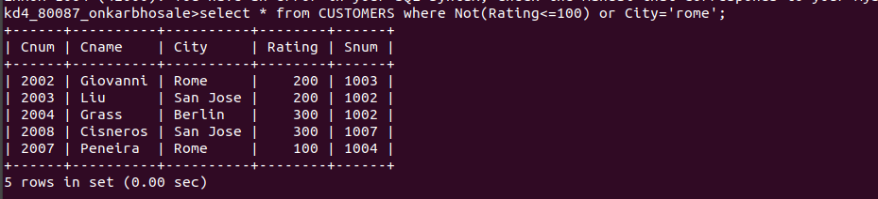

4) What will be the output from the following query?

Select from Orders

where (amt < 1000 OR NOT (odate = 1990-10-03'

AND cnum > 2003));
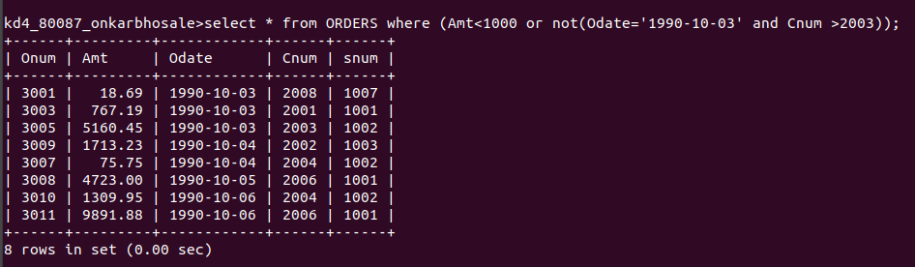

5) What will be the output of the following query?

Select from Orders where NOT ((odate = 1990-10-03' OR snum >1006) AND amt >= 1500);
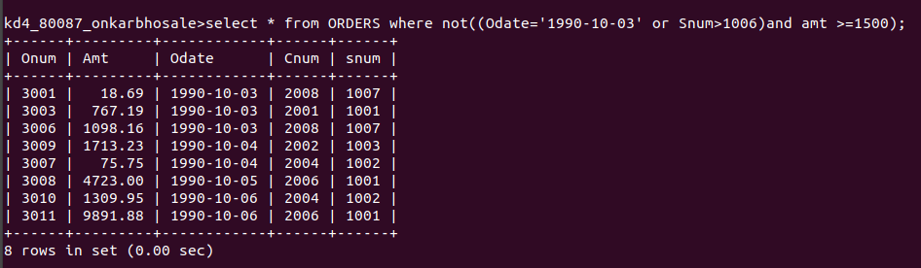

6) What is a simpler way to write this query?
Select snum, sname, city, comm From Salespeople where (comm>.12 OR comm <.14);


